Records Management Program

Table of Contents

Records Management Program Roadmap 2

Phase I: Assessment and Planning 2

Phase II: Policy & Framework Development 2

Phase III: Implementation 2

Phase IV: Monitoring and Continuous Improvement 2

Key Benefits of Implementation 3

Essential Records: Protecting What Matters Most in a Disaster 4

What Are Essential Records? 4

What Makes a Record Essential? 4

Protecting Essential Records 4

Ongoing Maintenance 5

Resources 5

Identifying Records 6

Sample Records Management Policy 7

Sample Litigation Hold Order Policy 10

# Records Management Program Roadmap

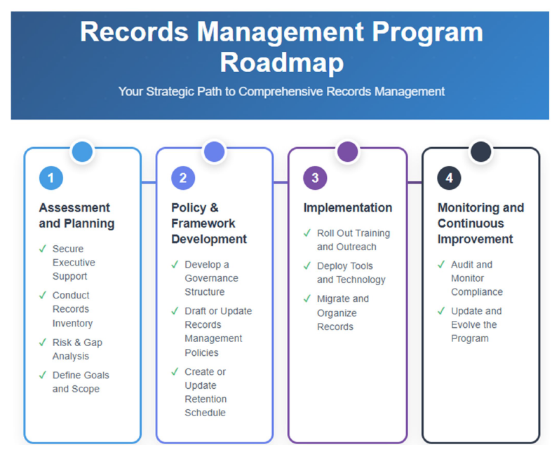

### Phase I: Assessment and Planning

* **Secure Executive Support:** Identify and brief key leaders. Align goals with agency mission and compliance needs.
* **Conduct Records Inventory:** Identify what records exist, formats, volumes, and locations. Interview departments to understand use and retention needs.
* **Risk & Gap Analysis:** Identify compliance risks (e.g., outdated policies, unmanaged data). Highlight gaps in training, tools, or retention schedules.
* **Define Goals and Scope:** Set clear objectives (e.g., legal compliance, efficiency, digital transformation). Prioritize critical functions and high-risk areas.

### Phase II: Policy & Framework Development

* **Develop a Governance Structure:** Assign roles (e.g., Records Coordinators, Data Stewards).
* **Draft or Update Records Management Policies**: Include retention schedules, classification schemes, handling of email and digital records, and destruction procedures (sample included).
* **Create or Update Retention Schedule:** Align with legal/regulatory requirements and business needs. Involve legal counsel and program leads in review.

### Phase III: Implementation

* **Roll Out Training and Outreach:** Educate staff on responsibilities and benefits. Provide targeted training by role or department.
* **Deploy Tools and Technology:** Use compliant repositories (e.g., Microsoft 365, SharePoint, or dedicated ECM systems). Integrate retention rules and searchability.
* **Migrate and Organize Records**: Apply metadata and classification to digital records.

Clean up redundant, outdated, trivial (ROT) content.

### Phase IV: Monitoring and Continuous Improvement

* **Audit and Monitor Compliance**: Conduct regular internal audits or reviews. Use dashboards and reports to track progress.
* **Update and Evolve the Program:** Revise policies as laws and technologies change.

Gather user feedback and update training.

## Key Benefits of Implementation

* **Regulatory Compliance:** Avoid fines and meet legal mandates (e.g., FOIA, HIPAA, state public records laws).
* **Improved Efficiency:** Staff can find information faster and reduce time spent managing outdated data.
* **Risk Reduction:** Prevent data breaches, unauthorized access, and loss of critical records by protecting citizen data.
* **Cost Savings:** Reduce storage costs and liability by disposing of records no longer needed.
* **Enhanced Transparency & Trust:** Demonstrates accountability to the public and oversight bodies.

# Essential Records: Protecting What Matters Most in a Disaster

## What Are Essential Records?

Essential records are the documents and data your organization needs to:

* Respond during an emergency
* Resume normal operations afterward
* Protect health, safety, legal rights, and property
* Avoid costly or impossible reconstruction
* Preserve the historical record of families and communities

They are a key component of your business continuity plan, helping ensure operations under any adverse conditions.

Also known as:

* Vital Records (Federal terminology)
* Mission-Critical/Business-Critical Records (Business terminology)

## What Makes a Record Essential?

A record is essential if it:

* Supports emergency response
* Enables continuity of core operations
* Protects the rights and well-being of residents
* Would be extremely costly or difficult to reconstruct
* Holds long-term community or historical significance

## Protecting Essential Records

To safeguard these records, agencies should:

1. Assess Risks

- Identify natural and human-made threats

2. Plan for Mitigation

- Implement procedures to minimize damage or loss

3. Apply Protection Methods

* Dispersal: Store copies in various formats and locations
* On-site Protection: Use fire-resistant cabinets or vaults
* Evacuation: Relocate records temporarily during emergencies
* Data Replication: Copy data to backup locations regularly
* Mirroring: Maintain real-time digital duplicates at a secondary site

# Ongoing Maintenance

* Review and update your essential records list regularly
* Ensure staff are trained on protection and recovery procedures
* Integrate records strategies with the broader business continuity plan

# Resources

* [NARA Essential Records Guide](https://www.ndit.nd.gov/sites/www/files/documents/operations-section/records-management/nara_essential_records_guide.pdf)
* [IPER Essential Records List](https://www.ndit.nd.gov/sites/www/files/documents/operations-section/records-management/IPER_essential_records_list.pdf)

# Identifying Records

# Sample Records Management Policy

Below is the NDIT Records Management Policy.

**Purpose:**

The purpose of this policy is to establish the principles, responsibilities, and requirements for managing the records of the state to ensure all agencies are in compliance with laws, regulations, policies, and best practices for managing records.

**Scope:**

This policy applies to all records created or received by employees of state agencies, boards, commissions, and educational institutions in the transaction of official business and preserved as evidence of the agency’s functions, organization, and activities.

**Background:**

North Dakota Century Code Chapter 54-46 requires agencies to:

1. Establish and maintain an active, continuing program for the economical and efficient management of the records of the agency.
2. Make and maintain records containing adequate and proper documentation of the organization, functions, policies, decisions, procedures, and essential transactions of the agency.

**Authority:**

North Dakota Century Code Chapter 54-46 - Records Management <http://www.legis.nd.gov/cencode/t54c46.pdf>

**Policy:**

It is state agencies responsibility to preserve all official records in accordance with applicable statutory and regulatory requirements, and to promote access to information by staff, partners, and the public, as appropriate. Agencies are required to establish and maintain a records management program meeting the following minimum requirements:

1. Create, receive, and maintain official records providing adequate and proper documentation as evidence of the agency’s business activities.
2. Manage records, regardless of format, in accordance with applicable statutes, regulations, and policies.
3. Maintain electronic records to ensure they are accessible throughout their entire life cycle.
4. Secure records to protect the legal and financial rights of the government and persons affected by government activities.
5. Dispose of records as specified in the approved records retention schedules. Records and other documents that are no longer sufficiently active to warrant retention in office space shall be removed to an inactive storage facility, if available.

**Roles and Responsibilities:**

Employees are ultimately responsible for creating and preserving records that adequately and properly document the organization, functions, policies, decisions, procedures, and essential transactions of the state.

The Records Management area within North Dakota Information Technology (NDIT) is responsible for providing the leadership, planning, overall policy, guidance, training, and general oversight of records management for state agencies.

NDIT Records Management can assist agencies in developing a Records Management Program for state agencies, including records retention schedules and a disposal process for both paper and electronic records.

Records Coordinator (typical roles):

* Review and coordinate the approval of agency records retention schedules.
* Distribute annual records disposal information.
* Coordinate records management issues and projects, including the following:
  + Identify and protect essential records o Assist in disaster recovery efforts o Respond to open records requests
  + Assist with litigation hold orders and discovery process
* Provide technical advice and training to all employees regarding the establishment and maintenance of effective records management programs.
* Conduct periodic evaluations of records management programs within the agency to determine the effectiveness of the program.

Managers/Supervisors:

* Submit updates to records retention schedules for records created and maintained by the division/section to the records coordinator.
* Ensure records are disposed according to the approved records retention schedule.
* Review records of terminating employees to determine if the records should be transferred to the employee assuming the job responsibilities of the departing employee, disposed according to the records retention schedule, or transferred to the State Archives.

Employees:

* Create and manage the records necessary to document the agency's official activities and business.
* Suggest additions, changes, or deletions to the records retention schedule and submit to your supervisor or agency records coordinator.
* Protect records of a confidential nature from unauthorized access.
* Dispose of records, regardless of format, according to the approved records retention schedule.
* Follow established procedures when transferring records to the State Archives.
* Implement proper recordkeeping procedures for efficient access and retrieval.

Records Retention Schedules for all agencies are available on NDIT’s website at <https://apps.nd.gov/itd/recmgmt/rm/recSer/retention.pdf>

# Sample Litigation Hold Order Policy

When the agencies are subject to or reasonably foresees that it will become involved in litigation, it will immediately implement “litigation hold” procedures to preserve relevant documents, electronic information, and other materials. A litigation hold is the process of identifying and preserving materials that may be relevant to the litigation. A “litigation hold” may impact the agency’s established records management program, requiring certain documents and electronic information to be retained for longer periods of time in an unaltered form.

The agency’s litigation hold, and preservation of evidence procedures may include any and/or all the following, based upon the situation:

1. If employees become aware of potential or actual litigation, they should contact the assistant attorney general or special assistant attorney general assigned to the agency. If an assistant attorney general or special assistant attorney general is not assigned to your agency, managers or supervisors should contact the North Dakota Solicitor General (Director of Civil Litigation) at 701-328-3640.

1. A Destruction Hold Notice (SFN 52376) ([http://www.nd.gov/eforms/Doc/sfn52376.pdf)](http://www.nd.gov/eforms/Doc/sfn52376.pdf) should be issued by the agency or its assigned assistant attorney general or special assistant attorney general based on currently available information. This can be revised after steps 3 and 4 are completed, if needed.

1. Appropriate agency personnel and the assistant attorney general or special assistant attorney general assigned to the agency, in conjunction with the North Dakota Solicitor General or the assistant attorney general designated to represent your agency in the litigation, will meet to determine whether a litigation hold should be implemented. “Appropriate agency personnel” includes the person or persons most knowledgeable about the relevant computer systems and network operations at the agency, the storage and retrieval of information, and procedures for backing up and archiving electronic information.

1. If a decision is made to implement a litigation hold, the individuals at the meeting will determine the scope of the litigation hold and how best to implement the litigation hold. The individuals at the meeting will:
   1. Identify the information, including electronically stored information that may be relevant to the litigation.
   2. Identify who may have the relevant documents, electronic information, or other materials in their possession.
   3. Identify all locations and storage media of such materials. With respect to electronic information, such locations may include:
      * Desktop and laptop computers
      * Network servers
      * Email servers
      * Handheld devices (cell phones, Blackberries, Palm Pilots)
      * Storage devices including CDs and ZIP drives
      * Offsite storage
      * Remote computers with network connections
      * CDs, DVDs, Memory Sticks, and other portable storage devices
      * Home computers or equipment
   4. Identify how best to implement the litigation hold, including how to preserve electronic data. Implementation includes:
      * Arranging for the appropriate individual (agency head, division director, assistant attorney

general), to send a written notice to employees at all applicable organizational levels specifying the documents and other materials as to which diligent efforts should be made to preserve and the method and places of preservation.

* + - Notifying the appropriate agency personnel of steps the agency needs to take to preserve electronic data, such as requesting segregation, removal, or exchange of computers or hard drives and the copying or cloning of drives.
    - Notifying the appropriate individual(s) within the agency or contact the NDIT Service Desk of steps needed to preserve electronic data, such as halting routine deletion of email, halting automatic updates or cleaning of computers, preserving backup tapes beyond the routine write-over cycle, or transferring certain electronic data to a dedicated server.
    - Determining how to monitor compliance with the litigation hold notice by periodically checking back with affected management and staff.
    - Determining how to keep a written record of steps taken to preserve documents, electronic information, and other materials to demonstrate compliance with the duty to preserve potential evidence.
    - If needed, determining who will assist in reviewing documents for production and assertion of privileges.
    - Determining how affected staff will be notified when the litigation hold has been canceled or removed.